Team Description Paper

1st Yifei Ren  
*Institute of Robotics and Automatic   
Information System*  
*Nankai University*Tianjin China  
Username in GitHub: FlyCole

2nd Ziqi Hu  
*Institute of Robotics and Automatic   
Information System*  
*Nankai University*Tianjin China  
Username in GitHub: Huziqi 2nd Jiashi Zhang  
*Institute of Robotics and Automatic   
Information System*  
*Nankai University*Tianjin China  
Username in GitHub: FansaOrz

2nd Shizhuo Yu  
*Institute of Robotics and Automatic   
Information System*  
*Nankai University*Tianjin China  
Username in GitHub: NKU16y

*Abstract*—Nowadays, the quality of nursing word decreases dominantly. To solve the problem, a medical management robot is designed to provide independent patient care. The robot is based on the turtlebot. Meanwhile, the robot has a telecommunication mechanism based on WeChat. Besides, the robot contains three subsystems: visual subsystem, speech subsystem and navigation subsystem. The visual subsystem can provide an image analysis including gender detection, age detection, emotion analysis, etc. Obtaining the image information, the speech subsystem can communication with the patient depend on different states of the patient detected by the visual subsystem. Based on different information extracted from the above two subsystems, the operator can order the robot to perform different tasks, in which the navigation subsystem can navigate the robot to right location with obstacle avoidance. All the communications between different subsystems are completed by the telecommunication mechanism based on WeChat.

Keywords—visual subsystem, speech subsystem, navigation subsystem, communication mechanism

# Introduction

At present, the continuous development of medical treatment provides convenience for all. However, nursing has been slower to develop. As a result of the time consuming in developing this labor skill, most of the hospitals chose to use non-professional nursing workers rather than nurses. Thus, the quality of taking care of the patients decreases significantly. In order to eliminate such low quality work at the same time introduce the large-scale autonomous management mode, a medical management robot is designed to replace nurses. The robot can be controlled remotely by the user through WeChat. Meanwhile, the robot has a visual subsystem, a speech subsystem, a navigation subsystem. To be specific, the robot can complete daily inspection, medicine delivery, emotion analysis and other tasks.

The rest of the paper is organized as follows: In Section II, the visual subsystem is designed to provide an emotion analysis function to check the emotional changes of patients. In Section III, the speech subsystem is designed to make robot easy to communicate with the patients. In Section IV, the navigation system is designed to navigate autonomously to different locations. In Section V, a remote communication mechanism based on WeChat is proposed to provide convenient way for users to manipulate the robot. Finally, the conclusion of the paper is presented in Section VI.

# Visual Subsystem

## Basic Idea of the Designed Visual Subsystem

The visual subsystem is designed to obtain the facial information of the patient, which can be used to analyze the patient’s gender, age, expression, emotion, complexion, etc. This system uses the emotion analysis as the core module. To be specific, the robot takes a picture when the *‘/patient_reach’* topic arises. Then the picture is analyzed by the Baidu AI system using online communication. Afterwards, the Baidu AI system returns the keyword selected by the user, which includes the emotion analysis. Finally, the analysis result is sent to WeChat, through which the nurses can obtain the state of the patient in real time. The flowchart of the visual subsystem is shown in Fig. 1.



1. The flowchart of the visual subsystem.

## Implementation Process of Visual Subsystem

When receiving the *‘/patient_reach’* topic, the *take_pic.py* file is run to take a picture of the patient. Then the picture is sent to the Baidu AI system using *gender_predict.py* file to make the emotion analysis. After analyzing, the results and the picture are sent to the WeChat.

## Baidu AI API

In order to use the Baidu AI API, registering an account on Baidu AI platform is the first thing. After you finish registering the account, you can login the account, and the interface is shown in Fig. 2.

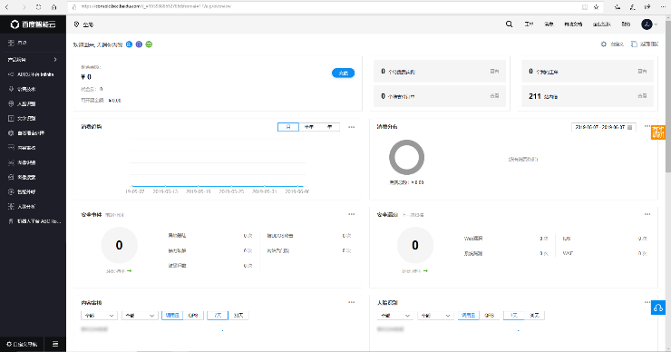

1. The inteface after login account.

If you want to create an application to do some analysis, you can select different modules provided in the left of the interface, as shown in Fig. 3.

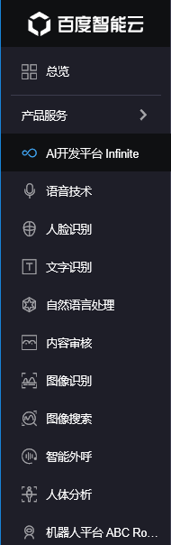

1. The different modules provided by Baidu AI platform.

This paper uses facial recognition module as the core function. Select the facial recognition module, the global interface will appear as shown in Fig. 4.

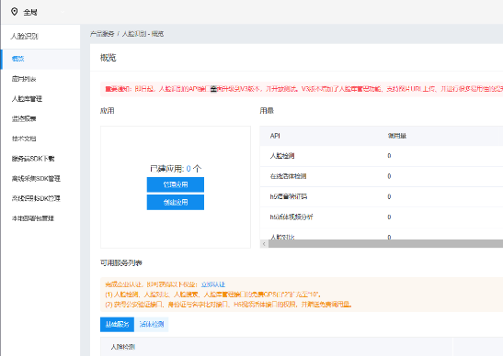

1. The global interface of facial recognition module.

You may select the ‘technical documentation’ as shown in Fig. 4 to learn how to use the API. In this project, we use the ‘face detection and attribute analysis’ API. The document introduces the ability, method of calling, sample code, sample returns of the API. The parts of the document are shown in Fig. 5-8.

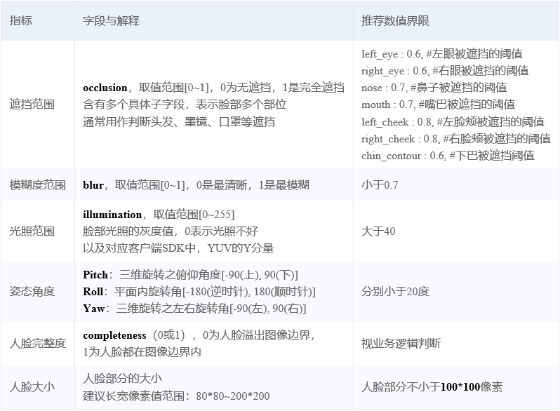

1. The ability of the API.

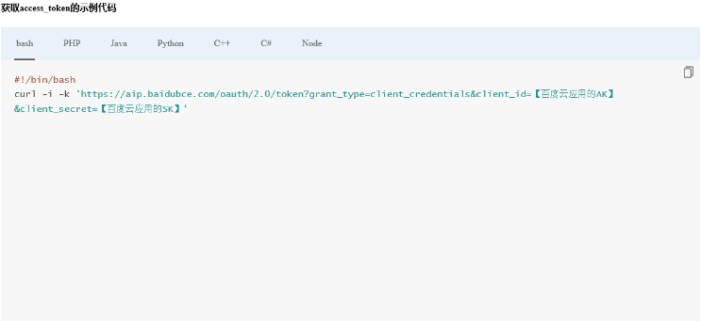

1. The obtaining access_token sample code.

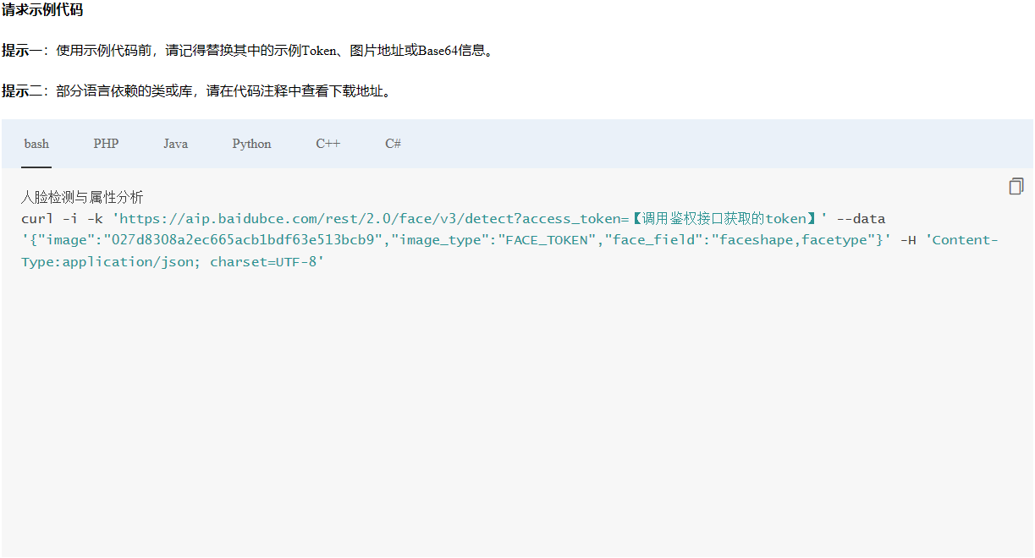

1. The request sample code.

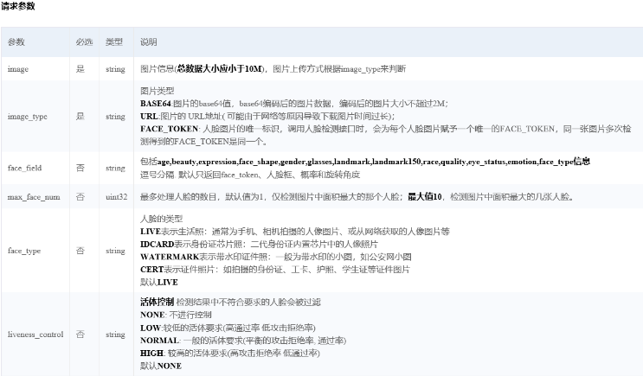

1. The request of the parameters.

After creating the application and calling for the API, the image taken from the *take_pic.py* can be analyzed by the API and the results can return to the main function. The information of the result can be obtained by the keywords in the dictionary. For example, if you want to obtain the emotion of the person, you must add ‘emotion’ parameter listed in the ‘face_field’ request parameter. The results include *angry*, *disgust*, *fear*, *happy*, *sad*, *surprise* and *neutral*, and the return format is shown in Fig. 9.

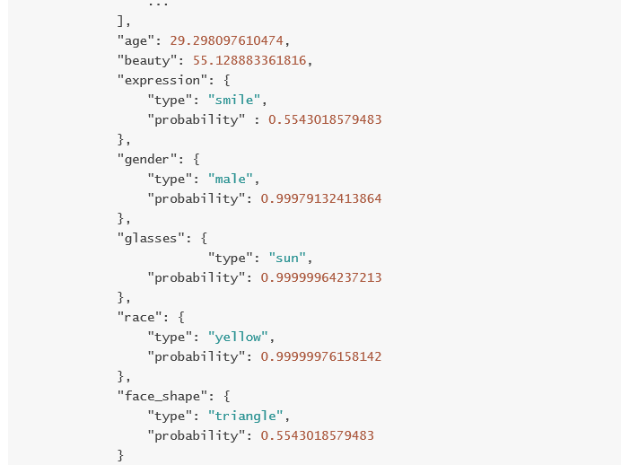

1. The request of the parameters.

## Unused Functionality and the Insufficiency

Baidu AI has many useful technology, it is a platform that contains image processing, natural language processing, speech recognition and other advanced technology. The precision of the Baidu AI is high enough to make the right decision in scenario such as in this paper. However, the Baidu AI is a online tool, when the internet is poor, it takes longer to receive the results. As a result, the widespread use of the Baidu AI has to wait for the coming of 5G era.

# Speech Subsystem

## Basic Idea of the Designed Speech Subsystem

The speech subsystem provides speech recognition module based on *xfei_ast* and *sound_play*, which both are existing speech packages. The subsystem can determine the way to greet the patient based on the result of the emotion analysis designed above. For example, when the patient is tested sad, the robot can comfort the patient. Besides, the robot can also assist in the daily inspection, such as asking the body temperature, the blood pressure of the patient or whether the patient has eaten the medicine. Afterwards, the answer can be transmitted to the doctors or the nurses through WeChat to help them make a diagnosis or take action.

## Implementation Process of Speech Subsystem

In details, by modifying the *iatt_publish_speak.cpp* file of the *xfei_asr* package, a publisher is built to send the recognized voice content every 15s. Then a subscriber is built through the *msg.reader.py* file, subscribing to the message and making an analysis based on its content, such as the body temperature or blood pressure information, which are recorded in a txt file. When finished, send the generated txt file out to the doctor.

# Navigation Subsystem

Turtlebot's navigation will be used to walk from the starting point to the pharmacy to get what the patient needs, then walk to the patient's bedside and hand it to the patient. After that, it starts to recognize the patient's current state through vision and acquire the patient's daily situation through human-robot interaction through voice.

## The Implementation of Localization

To realize Turtlebot navigation, *map_server* should be used to load a pre-built map. Gmapping is the most commonly used mapping method in ROS. Gmapping is an open source SLAM algorithm based on the filtering SLAM framework, which combines laser information with odometer information. At the same time, Gmapping is based on RBpf particle filter algorithm, which means the process of positioning and map building is separated, and the positioning is followed by the map building. With the map, we used the adaptive Monte Carlo localization (AMCL) algorithm for autonomous Localization of the robot. In the process of moving, the robot compared the data of the laser sensor with the existing map, and calculated the possible position of the robot based on the information of the odometer. In terms of robot path planning and controller, we mainly used the *move_base* package. *Move_base* used *Dijkstra* algorithm for path planning. In order to make the robot travel with maximum efficiency, it fitted the path into Bessel curve, and finally used the controller to control Turtlebot for autonomous navigation.

## DWA Function

Since our robot is used in a hospital, the safety of the robot is the most significant thing. In the autonomous navigation process of the robot, *move_base* uses dynamic window approach (DWA) to realize real-time obstacle avoidance function. Meanwhile. Turtlebot has bumper sensors that can immediately return when it touches obstacles.

# Communication Mechanism Based on WeChat

## Basic Idea of the Communication Mechanism Based on WeChat

The communication mechanism based on WeChat provide users a convenient way to manipulate the robot remotely. In order to achieve this goal, the *itchat.py* package is imported into programs, which is an open source API for WeChat, a commonly-used Chinese social networking app.

## Implementation Process of the Communication Mechanism Based on WeChat

In this project, we connect WeChat with ROS. The specific steps are listed below:

### An operator logs in to WeChat on laptop using QR code.

### The orders are sent using operator’s WeChat account.

### Extract the orders into feature-words that the laptop can understand what kind of task is received.

### The navigation subsystem receives the content of task and executes specific programs.

### The visual subsystem starts to work when the robot reaches the patient. The images taken from the visual subsystem are sent back through WeChat to the operator.

# Conclusion

The designed medical management robot can provide the convenient way for operators to manipulate the robot remotely through WeChat. The visual subsystem of the robot can make gender, age, skin, emotion analysis based on Baidu AI, which is a cloud compute API of Baidu company. The speech subsystem can make robot communicate with the patient, and pass signals after analyzing the dialogue. Then the navigation subsystem can execute different orders by navigating the robot to different locations. Finally, the communications of different subsystems are realized by the communication mechanism based on WeChat.